**PROFESSIONAL TRAINING II REPORT**

**entitled**

**Efficient Power Management and Integrated Billing System**

Submitted in partial fulfillment of the requirements for the award of

Bachelor of Engineering degree in Computer Science and Engineering with

specialization in Cyber Security

by

**DINESH S**

**41614018**



## DEPARTMENT OF COMPUTER SCIENCE AND ENGINEERING

**SCHOOL OF COMPUTING**

**SATHYABAMA**

## INSTITUTE OF SCIENCE AND TECHNOLOGY

## (DEEMED TO BE UNIVERSITY)

**Accredited with Grade “A++” by NAAC**

JEPPIAAR NAGAR, RAJIV GANDHISALAI,

CHENNAI – 600119

**OCTOBER 2023**

**SATHYABAMA**

**INSTITUTE OF SCIENCE AND TECHNOLOGY**

## (DEEMED TO BE UNIVERSITY)

**Accredited with A++ Grade by NAAC**

Jeppiaar Nagar, Rajiv Gandhi Salai,

Chennai – 600 119

[**www.sathyabama.ac.in**](http://www.sathyabama.ac.in/)

## 

## DEPARTMENT OF COMPUTER SCIENCE AND ENGINEERING

**BONAFIDE CERTIFICATE**

This is to certify that this Professional Training is the bonafide work of

**Mr DINESH.S (41614018)** who carried out the project entitled**“Efficient Power Management and Integrated Billing System”** under my supervision from January 2024 to April 2024.

**Internal Guide**

**Dr.B.U.Anu Barathi M.E.,Ph.D**

**Head of the Department**

**Dr. S. VIGNESHWARI, M.E., Ph.D.,**

**Submitted for Viva voce Examination held on __________________**

**Internal Examiner External Examiner**

**DECLARATION**

I, **DINESH S (41614018)** hereby declare that the Professional Training Report-II entitled **“Efficient Power Management and Integrated Billing System”** done by me under the guidance of **Dr.B.U.Anu Barathi M.E.,Ph.D** is submitted in partial fulfilment of the requirements for the award of Bachelor of Engineering degree in Computer Science and Engineering with specialization in Cyber Security

.

**DATE:**

## PLACE: SIGNATURE OF THE CANDIDATE

**ACKNOWLEDGEMENT**

I am pleased to acknowledge my sincere thanks to **Board of Management** of **SATHYABAMA** for their kind encouragement in doing this project and for completing it successfully. I am grateful to them.

I convey my thanks to **Dr. T.Sasikala M.E., Ph.D.**, **Dean**, School of Computing, **Dr. S.Vigneshwari M.E., Ph.D., Head of the Department** **of** **Computer Science and Engineering** for providing me necessary support and details at the right time during the progressive reviews.

I would like to express my sincere and deep sense of gratitude to my Internal Guide **Dr.B.U.Anu Barathi M.E.,Ph.D** for his/her valuable guidance, suggestions and constant encouragement which paved way for the successful completion of my phase-1 professional Training.

I wish to express my thanks to all Teaching and Non-teaching staff members of the **Department of Computer Science and Engineering** who were helpful in many ways for the completion of the project.

**COURSE CERTIFICATE**

**ABSTRACT**

In today's ever-evolving technological landscape, the efficient management of power resources is paramount to both sustainability and economic viability. This paper presents a comprehensive solution aimed at optimizing power consumption and streamlining billing processes through the integration of cutting-edge technologies and innovative methodologies.The proposed system centers on real-time monitoring and control of electrical devices, facilitated by advanced sensors, machine learning algorithms, and seamless IoT connectivity. By harnessing the power of data analytics, the system dynamically adjusts power allocation based on fluctuating demand patterns and user preferences, ensuring optimal resource utilization while minimizing waste.Furthermore, the integration of an intuitive billing system adds a layer of transparency and accountability to the process. By accurately tracking individual device usage, the system enables fair and precise invoicing, thereby promoting equitable cost distribution among users. This not only fosters a sense of fairness but also incentivizes energy-conscious behavior, ultimately contributing to a more sustainable future.Moreover, the system offers users comprehensive insights into their energy consumption patterns, empowering them to make informed decisions and adopt more efficient practices. With a user-friendly interface and intuitive design, the system promotes user engagement, encouraging active participation in energy management efforts.In conclusion, this innovative solution represents a significant step towards achieving efficient power management and billing integration. By leveraging advanced technologies and fostering user engagement, it not only optimizes operational costs but also drives positive environmental impact, paving the way for a more sustainable and energy-efficient future.

| **CHAPTER NO.** | **TITLE** | | **PAGE NO.** |
| --- | --- | --- | --- |
|  | **ABSTRACT** | | v |
|  | **LIST OF FIGURES** | | vii |
| 1 | **INTRODUCTION**  1.1 Overview | | 1 |
| 2 | **LITERATURE SURVEY**  2.1 survey | | 3 |
| 3 | **REQUIREMENTS ANALYSIS** | |  |
|  | 3.1 | Objective | 9 |
|  | 3.2 | 3.2.1 Hardware Requirements  3.2.2 Software Requirements | 11  16 |
| 4 | **DESIGN DESCRIPTION OF PROPOSED PRODUCT** | |  |
|  | 4.1 | Proposed Product  4.1.1 Ideation Map/Architecture Diagram  4.1.2 Various stages  4.1.3 Internal or Component design structure  4.1.4 working principles | 20  21  22  27  30 |
|  | 4.2 | Features  4.2.1 Novelty of the Project | 51 |
| 5 | **CONCLUSION** | | 55 |
|  | **References** | | 56 |

**TABLE OF CONTENTS**

|  |  |  |
| --- | --- | --- |
|  | **LIST OF FIGURERS** |  |
| **FIGURE**  **NO** | **FIGURE NAME** | **PAGE NO.** |
| 1. | 8051 series microcontroller | 13 |
| 2. | Voltage Regulator | 14 |
| 3. | Diodes | 14 |
| 4. | LED | 15 |
| 5. | Transistor | 15 |
| 6. | Bulb | 16 |
| 7. | Push Button | 16 |
| 8. | IR LED’S | 17 |
| 9. | IR Receviers | 17 |
| 10. | Intel Core i5 | 18 |
| 11. | OPERATING SYSTEM | 18 |
| 12. | FLOW CHART | 20 |
| 13. | Ideation Map | 21 |
| 14. | System Architecture | 22 |
| 15. | Mind map | 22 |
| 16. | General Login | 45 |
| 17. | Calculate electricity bill | 46 |
| 18. | Deposited Money & Notification History | 47 |
| 19. | Admin Login page | 48 |
| 20. | Addbill & system exited | 49 |
| 21. | Domestic Output (WITHOUT COUNTING) | 50 |
| 22. | Commercial Output (WITH COUNTING) | 52 |

**CHAPTER 1**

**INTRODUCTION**

**1.1 OVERVIEW**

The Efficient Power Management and Integrated Billing System is a comprehensive solution designed to address the challenges of optimizing energy consumption and simplifying billing processes. At its core, the system employs cutting-edge technologies to create a smart and adaptive infrastructure.The implementation of Internet of Things (IoT) connectivity forms the backbone of the system, enabling seamless communication and data exchange among interconnected devices. This connectivity facilitates real-time monitoring and control of electrical devices, allowing for dynamic adjustments based on demand and user preferences.Advanced sensors play a pivotal role in the system by collecting real-time data on power consumption and device usage. These sensors provide valuable insights into energy patterns, contributing to informed decision-making for optimizing power allocation. Machine learning algorithms enhance the system's capabilities by analyzing historical data and user behaviors, allowing it to predict and adapt to changing usage patterns, ultimately maximizing energy efficiency.A user-friendly interface is integrated into the system to enhance user engagement. This interface empowers users to monitor their energy usage, set preferences, and gain insights into their consumption patterns. By fostering transparency and accountability, the system encourages responsible energy practices among users.One of the distinguishing features of the system is its integrated billing module. This component tracks individual device usage, ensuring accurate and transparent billing. The system promotes fair distribution of costs among users, creating a financially equitable environment.Overall, the Efficient Power Management and Integrated Billing System represents a holistic approach to energy management. It not only optimizes power consumption through advanced technologies but also simplifies the billing process, making it an ideal solution for promoting sustainability and efficiency in both residential and commercial settings.

**CHAPTER 2**

**LITERATURE REVIEW**

**2.1 SURVEY**

Efficient Power Management and Integrated Billing Systems have gained significant attention in recent years due to the growing demand for sustainable energy practices and the need for streamlined billing processes. Researchers have explored various technologies and methodologies to address the challenges associated with optimizing power consumption and improving billing accuracy. Studies have delved into the application of Internet of Things (IoT) in energy management systems, highlighting its role in enabling real-time communication and control of devices. The integration of sensors for monitoring power usage has been a focus, with research demonstrating their effectiveness in providing granular data for informed decision-making. Machine learning algorithms have been extensively researched to predict and adapt to changing energy consumption patterns. These studies emphasize the potential of artificial intelligence in dynamically adjusting power allocation based on historical data and user behaviors. User engagement and behavior studies have investigated the impact of user-friendly interfaces on promoting energy-conscious practices. Literature suggests that transparent and interactive interfaces empower users to monitor and control their energy usage effectively .Billing systems in the context of energy management have been a subject of research, with a focus on developing integrated solutions. Researchers have explored the challenges and benefits of incorporating billing modules that track individual device usage, ensuring fair and accurate distribution of costs. While existing literature provides valuable insights into individual aspects of efficient power management and integrated billing systems, there remains a need for comprehensive studies that holistically address the intersection of these components. Future research could focus on the scalability, security, and practical implementation of such systems in diverse settings.

**2.2 Existing System**

1. **Graeme Gooday The morals of measurement: accuracy,**

**irony, and trust in late Victorian electrical practice,**

**Cambridge University Press, 2019**

**Advantages:**

**1.Historical Insight**

The book likely provides valuable historical insights into the development of electrical measurement practices during the late Victorian era. Understanding the historical context can offer a foundation for appreciating the evolution of technology and its societal impact.

**2.Ethical Considerations**

Exploring the "morals of measurement" suggests an examination of ethical considerations in the field of electrical practice. This can be advantageous in fostering a deeper understanding of the ethical dilemmas and decisions faced by practitioners during that time.

**3**.**Cultural and Societal Perspectives**

The book may shed light on how societal values and cultural factors influenced the practices and perceptions surrounding electrical measurements. This broader perspective can contribute to a more comprehensive understanding of technological advancements in their cultural context.

**Disadvantages**

**1.Limited Applicability**

The historical focus of the book may limit its applicability to contemporary electrical practices. Technological advancements and changes in societal norms might render some aspects of the late Victorian era less relevant to current discussions on measurement in the electrical field.

**2.Access to Specifics**

Without access to the book's specific content, it is challenging to evaluate the depth and accuracy of the information provided. The reader may need additional sources to corroborate and verify the historical details presented in the book.

**3.Niche Audience**

The subject matter may appeal primarily to a niche audience interested in the history and philosophy of science and technology. This might limit its accessibility or relevance to a broader readership.

**2.** **Arimoro, T. A., Oyetunji, A. K., &Odugboye, O. E. (2019). Analysis of Electricity Billing System in Corporate Buildings in Lagos, Nigeria. Studies, 1(6), 10-20**

**Advantages**

**Historical Insight**

The book likely provides valuable insights into the electrical progress made over a forty-year period leading up to 1930. It can offer a historical perspective on the development of electrical technologies, applications, and their impact on society during that time.

**Primary Source Material**

If the book includes primary source material or firsthand accounts, it could serve as a valuable resource for researchers and historians studying the history of electrical engineering and technology.

**Contextual Understanding**

Readers can gain a better understanding of the technological, economic, and societal context in which electrical advancements occurred. This contextual information is crucial for appreciating the challenges, innovations, and implications of the time.

**Disadvantages**

**Outdated Information**

Given the publication date of 1930, the book may contain outdated information, particularly regarding technological advancements and societal changes since then. Readers should be cautious about relying on the book for current or accurate technical details.

**Limited Scope**

The book might focus on specific aspects of electrical progress or provide a narrow perspective based on the author's experiences or interests. This limited scope could restrict its applicability to a broader understanding of the field.

**Biased Perspective**

Depending on the author's background and affiliations, there is a possibility of bias in the presentation of events and progress. Readers should be aware of the author's perspective and potential influence on the narrative.

**Accessibility**

Given its age and potential limited availability, the book might be challenging to access, making it less accessible to a wider audience. This could limit its impact on contemporary discussions or research in the field.

**3.Eugenii Katz. "Blathy". People.clarkson.edu. Archivedfrom the original on June 25, 2018.**

**Advantages**

**Accessibility**

Online sources are generally easily accessible, providing a convenient way for users to obtain information without physical constraints. This accessibility allows a broader audience to benefit from the content.

**Archived Information**

The fact that the information is archived suggests that it has been preserved for a period of time. This can be advantageous for historical research or for referencing information that might no longer be available on the original website.

**Credibility of Author**

If Eugenii Katz is a reputable and authoritative source on the topic, the information presented may carry more weight. Evaluating the author's credentials can enhance the credibility of the content.

**Disadvantages:**

**Outdated Information**

Archived content may become outdated over time, particularly if the original source is not regularly updated. Users should be cautious about relying on information that might have changed since the time of archiving.

**Link Reliability**

If the original link to the source is not provided or if it is broken, users may have difficulty verifying the information or accessing the source directly. This can affect the reliability of the information.

**Limited Context**

Online sources, especially when archived, may lack context or details that could be crucial for a comprehensive understanding of the topic. Users should be aware of the potential limitations in the scope or depth of the information.

**Authenticity Concerns**

In some cases, archived content might be altered or manipulated, raising concerns about the authenticity of the information. It's important to cross-reference information with other reliable sources to verify its accuracy.

**4.The Rise of General Electric, Cambridge University Press,2003**

**Advantages**

**Historical Insight**

A book focusing on the rise of a significant company like General Electric can provide valuable historical insights into the development of the company, the industries it influenced, and broader economic trends.

**In-depth Analysis**

Academic books often offer in-depth analysis and research, providing readers with a comprehensive understanding of the subject matter. This can be particularly useful for students, scholars, and professionals seeking detailed information.

**Credibility**

Cambridge University Press is a reputable academic publisher, and books published by such institutions often go through a rigorous peer-review process. This can enhance the credibility and reliability of the information presented in the book.

**Disadvantages**

**Narrow Focus**

Depending on the author's approach, the book may have a narrow focus on specific aspects of General Electric's rise, potentially excluding broader industry or economic contexts. Readers should be aware of the book's scope and limitations.

**Outdated Information**

If the book was published several years ago, it might not include recent developments in General Electric's history. It's important to consider the publication date and supplement the information with more recent sources if needed.

**Potential Bias**

Authors may have certain perspectives or biases that could influence their interpretation of historical events. Readers should critically evaluate the author's standpoint and consider alternative viewpoints when available.

**Accessibility**

Academic books, especially those published by prestigious presses, might be more geared toward a scholarly audience. This could make the content less accessible to general readers who are not familiar with academic writing or specialized terminology.

**CHAPTER 3**

**REQUIREMENTS ANALYSIS**

**3.1 OBJECTIVE OF THE PROJECT**

The objective of this project is to develop an efficient power management and integrated billing system that will improve the overall performance and cost-effectiveness of power usage for both individuals and businesses. This system will provide users with tools and resources to monitor and control their energy consumption, as well as streamline the billing process for utility companies. The key objectives of this project are as follows

1. **Enhance Energy Efficiency**

The primary objective of this project is to improve energy efficiency by providing users with real-time data on their energy consumption. This will enable them to identify areas of high energy usage and make necessary adjustments to reduce their overall energy consumption.

**2. Reduce Energy Costs**

By improving energy efficiency, this system aims to reduce energy costs for both individuals and businesses. It will provide users with insights into their energy usage patterns and suggest ways to reduce energy consumption, resulting in lower utility bills.

**3. Optimize Power Distribution**

Efficient power management is crucial for ensuring a stable and reliable power supply. This system will help utility companies to optimize power distribution by identifying areas of high energy demand and adjusting power supply accordingly.

**4. Integrate Billing Process**

The current billing process for utility companies is often complex and time-consuming. This system aims to simplify and streamline the billing process by integrating all energy usage data and generating accurate and timely bills for users.

**5. Encourage Sustainable Practices**

By promoting energy efficiency and reducing energy costs, this system will encourage users to adopt more sustainable energy practices. It will also provide incentives for users who consistently reduce their energy consumption.

**6. Improve User Experience**

The system will provide a user-friendly interface for users to easily access and understand their energy usage data. It will also allow them to set energy usage goals and track their progress, making the experience more interactive and engaging.

**7. Enhance Data Management**

Efficient data management is essential for the success of this project. The system will have robust data management capabilities, including data collection, storage, and analysis, to provide accurate and reliable insights into energy usage patterns.

Overall, the objective of this project is to create a comprehensive and user-friendly power management and integrated billing system that will benefit both individuals and businesses, while also promoting sustainable energy practices.

**3.2 REQUIREMENTS**

**3.2.1 *HARDWARE REQUIREMENT***

The hardware requirements for an Efficient Power Management and Integrated Billing System will depend on the specific features and functionalities you plan to incorporate into the system. Below are general hardware considerations for such a system:

**1.8051series microcontroller**

The 8051 series microcontroller is a popular choice for efficient power management and integrated systems in various applications. One example of its usage is in smart home automation systems. The 8051 microcontroller can be used to control and manage the power consumption of various devices in the home, such as lights, appliances, and heating/cooling systems.

 **Fig.1 8051series microcontroller**

**2.voltage Regulator**

A voltage regulator is an electronic device used to maintain a stable and consistent voltage output from a power source. It is commonly used in various electronic devices and systems to efficiently manage power and ensure their proper functioning.

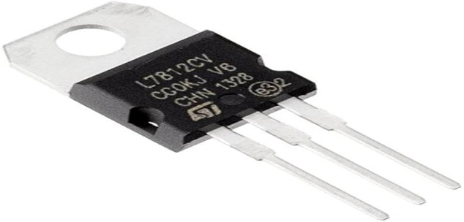

**Fig.2 voltage Regulator**

**3.Diodes**

Diodes are essential components used in power management and integrated systems to ensure efficient energy flow and system operation. They are semiconductor devices that allow current to flow in one direction while blocking it in the opposite direction.



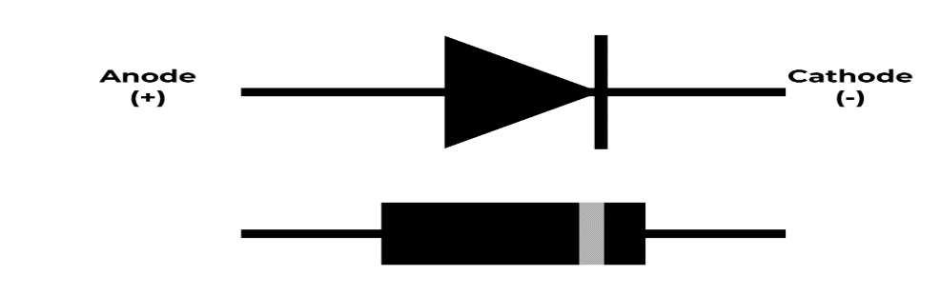

**Fig.3 Diodes**

**4.LED**

LEDs are also used in integrated systems for various purposes. LEDs are also used in electronic devices such as smartphones, laptops, and TVs for backlighting. LEDs are versatile and efficient in power management and integrated systems. Whether it is for lighting, indicators, traffic signals, or electronic devices, the use of LEDs contributes to reduced energy consumption and cost, making them a popular  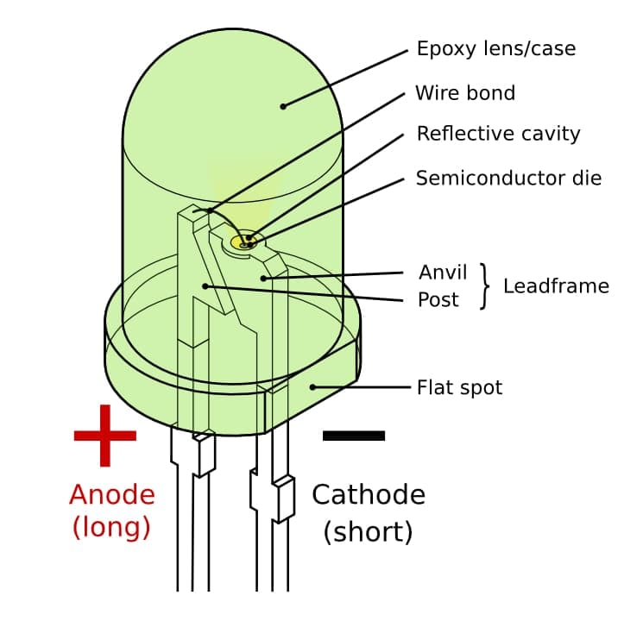

**Fig.4 LED**

**5.Transistor**

In integrated systems, transistors play a crucial role in controlling the flow of data and signals between different components, improving overall system performance. It used in an efficient way to produce current electricity.

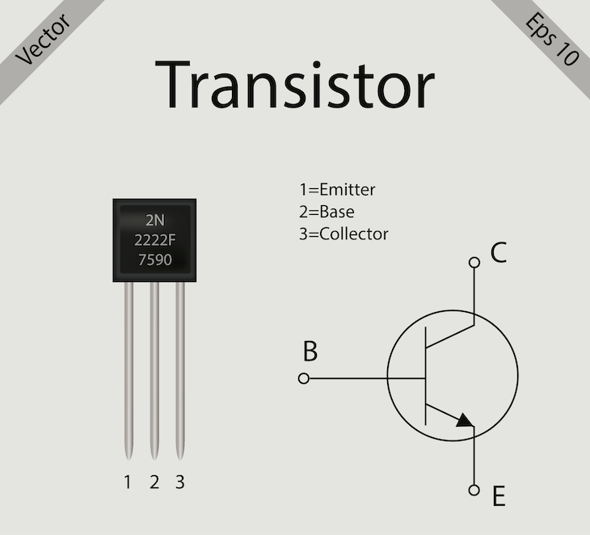

**Fig.5 Transistor**

**6.Bulb**

The lamp is equipped with energy-saving LED bulbs for efficient power management, reducing electricity usage and costs.Its integrated system allows for easy dimming and scheduling of lighting, optimizing energy usage and reducing wasted electricity.The lamp's motion sensor feature automatically turns off the lights when no one is present, further conserving energy.



**Fig.6 Bulb**

**7.Push Button**

A push button can be used for efficient power management by allowing users to easily turn off or put devices into sleep mode when not in use, reducing energy consumption.The push button can also be integrated into a system to automatically shut down or put devices on standby mode after a certain period of inactivity, further optimizing power usage.This feature is particularly useful in large-scale systems, such as office buildings or smart homes, where multiple devices are connected and can be controlled with a single push of a button.

 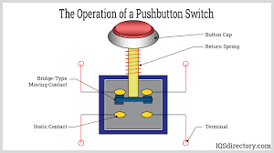

**Fig.7 Push Button**

**8.IR LED’s**

In Efficient Power Management and Integrated Billing Systems, IR LEDs are employed to enable seamless communication between smart devices and sensors. These IR LEDs facilitate data transmission, allowing for real-time monitoring of power consumption and enabling accurate billing. By using IR technology, the system ensures secure and reliable communication, contributing to efficient energy management and transparent billing processes.



**Fig.8 IR LED’s**

**9.IR Receivers (Infrared sensor)**

IR receivers are employed to capture signals from remote controls, facilitating user-friendly interaction with devices. These receivers enable seamless control of power-consuming appliances and contribute to energy efficiency by allowing users to remotely manage device operations. Additionally, IR receivers play a crucial role in tracking usage patterns, aiding in precise billing calculations based on individual device consumption. This technology enhances both user convenience and the accuracy of billing information in integrated systems.

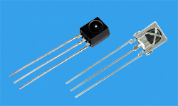

**Fig.9 IR Receivers**

**3.2.2 *SOFTWARE REQUIREMENTS***

**PROCESSOR**

Intel Core i5 or a better processor

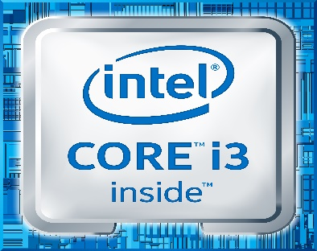

**Fig.10**

**OPERATING SYSTEM**

Windows 8, Windows 10, MAC OS, Linux, CMD, (which stands for **Command Prompt**), A text editor or IDE **(Integrated Development Environment)** to write and execute the code.



**Fig.11**

**MEMORY** 8 GB RAM or higher

**HARD DISK SPACE**  Minimum 30 GB or higher

**PROGRAMMING LANGUAGE** C++ (or “**C-plus-plus**”)

**COMPILER** Dev-C++, Codeblock **Fig.12**

**3.2.3 FLOW CHART**

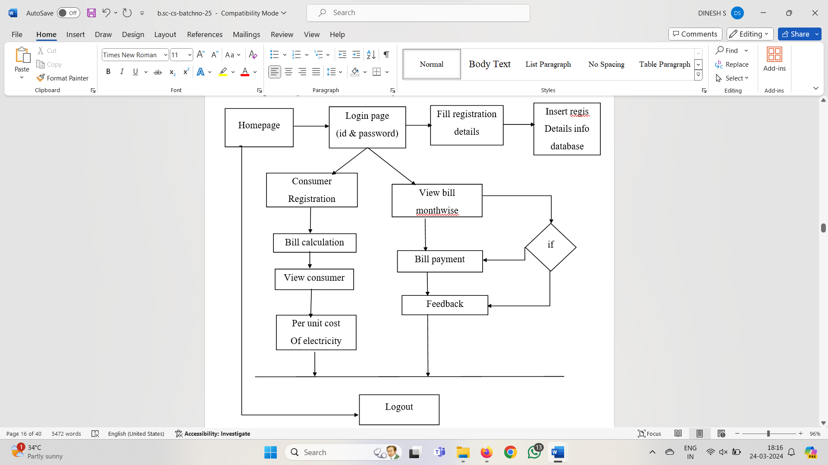

**Fig.13.1 Flowchart [Billing OR Payment Part]**

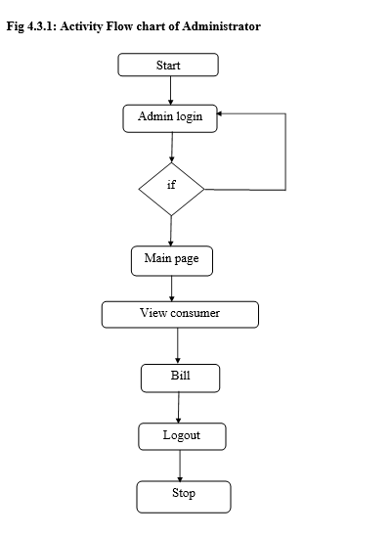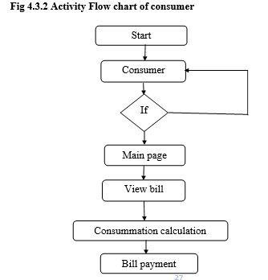

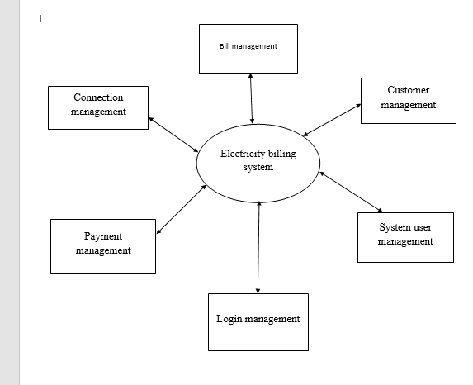

**Fig.14 ONE UNIT OF ELECTRICITY COST IN TAMILNADU**

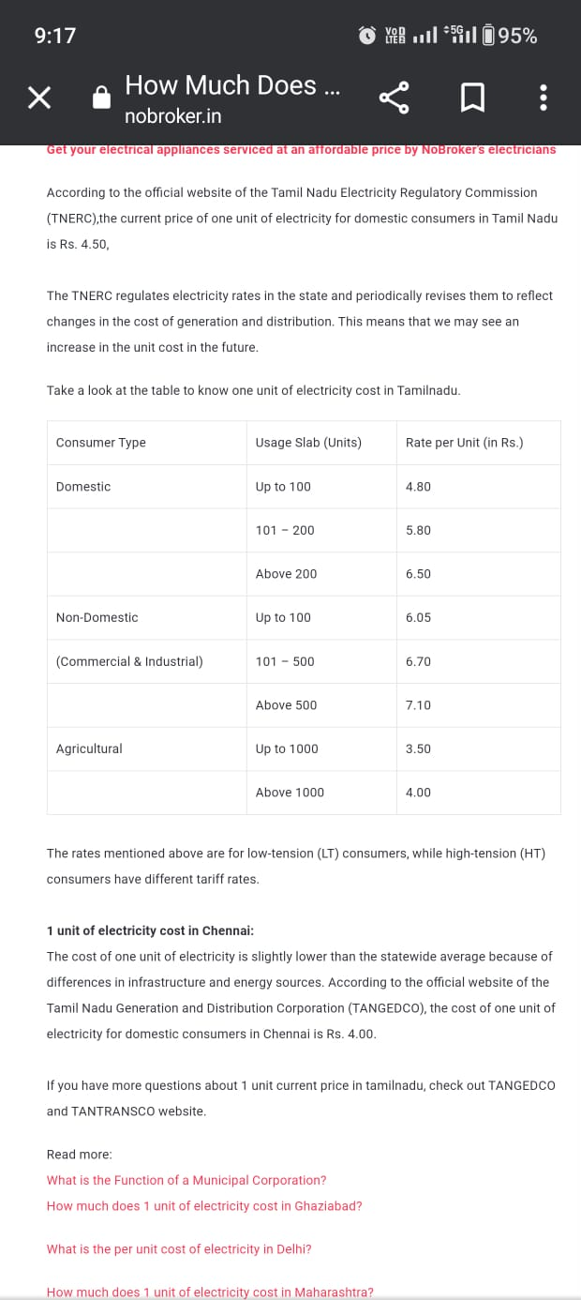

# **CHAPTER 4**

**DESIGN DESCRIPTION OF PROPOSED PROJECT**

**4.1 PROPOSED METHODOLOGY**

Developing an efficient power management and integrated billing system involves combining technologies for monitoring, control, and billing to optimize energy consumption. Below is a proposed methodology that can guide the development of such a system:

**1. System Requirements and Analysis**

Define the scope and objectives of the power management and billing system. Identify key stakeholders, including consumers, utility providers, and system administrators.

**2.Smart Metering Infrastructure**

Implement smart meters for real-time monitoring of energy consumption at the consumer level. Integrate advanced sensors and communication technologies to collect and transmit data securely.

**3.Data Collection and Analysis**

Set up a central data repository for storing and processing the collected energy consumption data.Utilize data analytics tools to analyze patterns, peak usage times, and potential areas for improvement.

**4. Remote Monitoring and Control**

Develop a user-friendly interface for consumers to monitor and control their energy usage remotely. Enable real-time alerts for abnormal energy consumption patterns or system failures.

**5.Energy Efficiency Recommendations**

Provide consumers with personalized recommendations for improving energy efficiency based on their usage patterns.integrate tips, notifications, and incentives to encourage energy conservation practices.

**6. Integrated Billing System**

Implement a transparent and automated billing system that accurately reflects energy consumption. Integrate the billing system with the smart metering infrastructure to eliminate manual readings and errors.

**7. Security and Privacy**

Implement robust security measures to protect the integrity and confidentiality of the collected data. Ensure compliance with data privacy regulations and establish clear policies for data access and sharing.

**8. Scalability and Interoperability**

Design the system with scalability in mind to accommodate future growth in the number of users and devices.Ensure interoperability with existing and emerging technologies in the energy sector.

**9. Testing and Validation**

Conduct thorough testing of the system components, including simulated load testing, security audits, and user acceptance testing.Validate the system in a controlled environment before deploying it to a larger user base.

**10. Deployment and Training**

Roll out the system gradually, starting with a pilot phase to identify and address any issues. Provide training to end-users, administrators, and support staff to ensure effective use and maintenance of the system.

**11. Continuous Improvement**

Establish a framework for continuous monitoring, feedback, and improvement based on user experiences and evolving technologies. Incorporate user feedback and technological advancements to enhance the system over time.

**4.1.1 *Ideation Map/System Architecture***

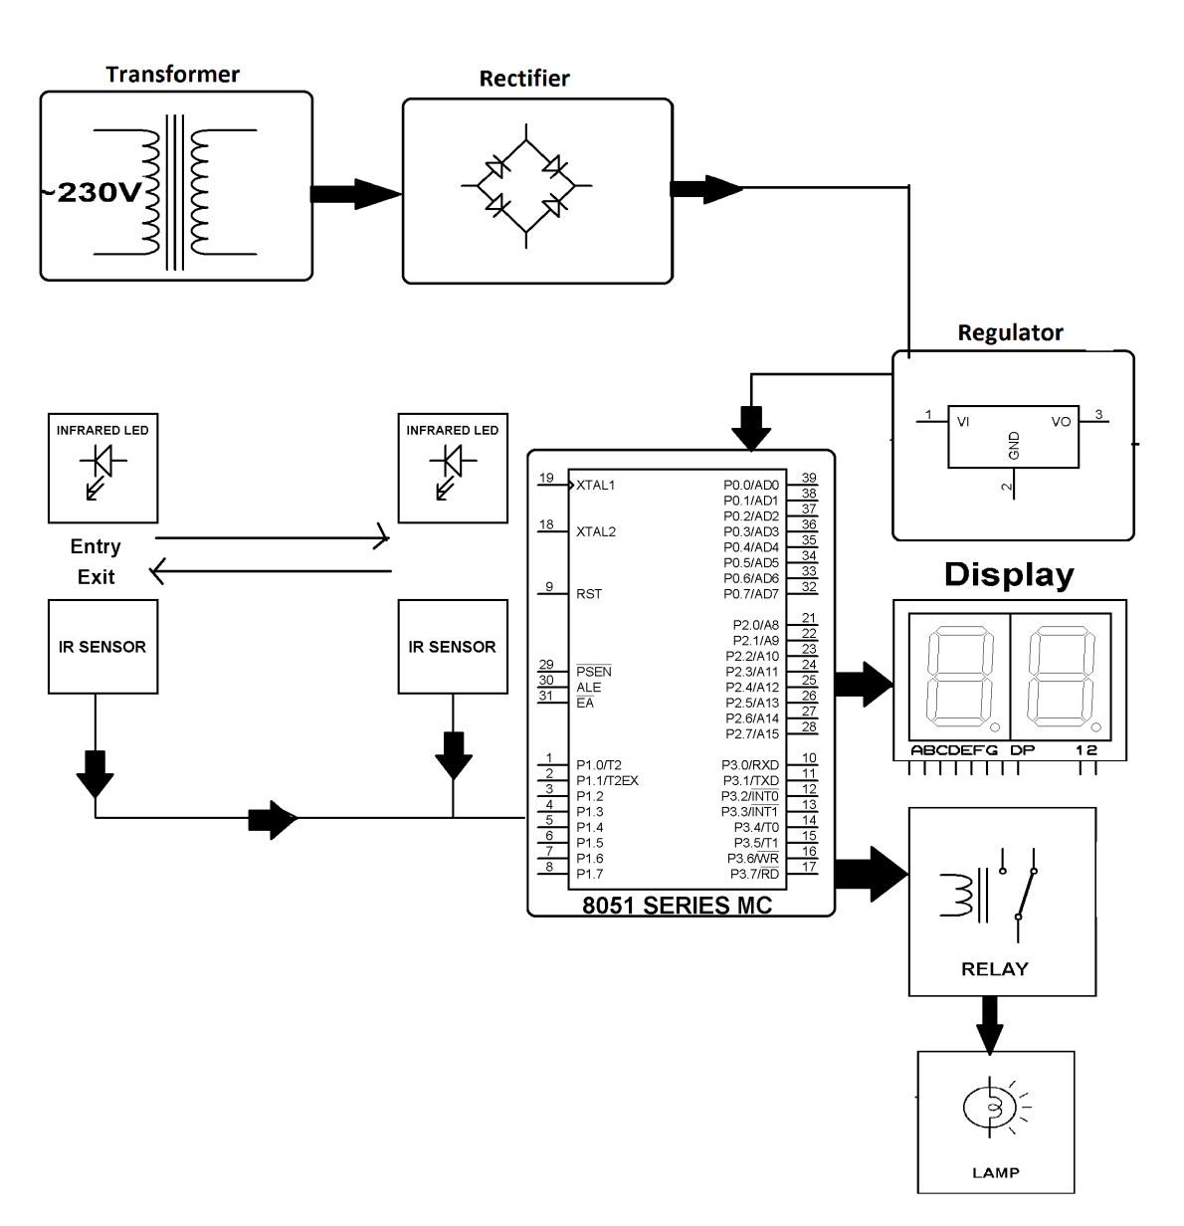

**Fig.10 Ideation Map*/System Architecture***

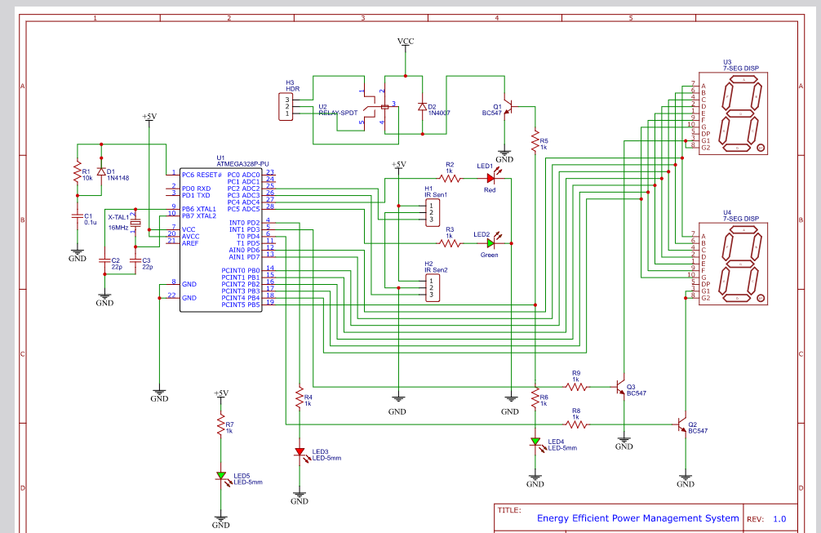

**Fig.11 Circuit Diagram**

**GENERAL LOGIN MENU [Flow Chart]**

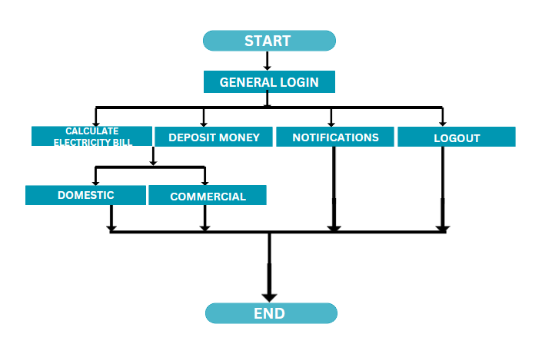

**ADMIN LOGIN MENU [Flow Chart]**

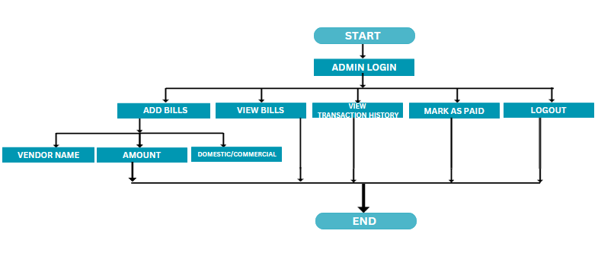

**4.1.2 *Various Stages***

Efficient power management and integrated billing systems are essential components in today's dynamic energy landscape. Implementing a robust system involves several stages to ensure optimal energy usage, cost efficiency, and accurate billing. Here are various stages for developing an efficient power management and integrated billing system**:**

**1. System Analysis and Planning**

Identify energy requirements and usage patterns.Assess the existing infrastructure and energy sources. Define goals and objectives for power management and billing.

**2. Metering and Data Collection**

Install smart meters and sensors to measure energy consumption in real-time. Implement advanced metering infrastructure (AMI) for accurate data collection.Integrate data from various sources, such as IoT devices and building management systems.

**3. Data Aggregation and Processing**

Aggregate and process data collected from meters and sensors.Utilize data analytics to identify patterns, trends, and anomalies. Implement algorithms for load forecasting and demand response**.**

**4. Communication Infrastructure**

Establish a robust communication network for seamless data transfer.Implement protocols such as MQTT or CoAP for efficient communication between devices. Ensure secure and reliable data transmission.

**5. Energy Storage and Backup Systems**

Integrate energy storage solutions for load balancing and peak demand management. Implement backup systems to ensure continuity in case of power outages.

**6. Automation and Control Systems**

Implement automation systems for optimal control of energy-consuming devices. Utilize smart grid technologies for real-time control and monitoring. Integrate with building automation systems to optimize energy usage.

**7. Demand Response Management**

Develop strategies for demand response to reduce peak loads during high-demand periods.Implement pricing schemes to incentivize users to shift energy consumption to off-peak hours**.**

**8. Billing System Integration**

Integrate billing functionalities with the power management system.Implement accurate metering for billing purposes**.**

**9. User Interface and Reporting**

Develop a user-friendly interface for consumers to monitor and manage their energy usage. Generate detailed reports on energy consumption, costs, and efficiency.Provide alerts and notifications for unusual usage patterns or billing discrepancies.

**10. Regulatory Compliance and Standards**

Ensure compliance with local and international energy regulations. Adhere to industry standards for interoperability and data security. Stay updated on evolving standards and regulations related to power management.

By following these stages, organizations can develop a comprehensive power management and integrated billing system that promotes efficiency, sustainability, and cost-effectiveness**.**

**4.1.3*****Internal or Component design structure***

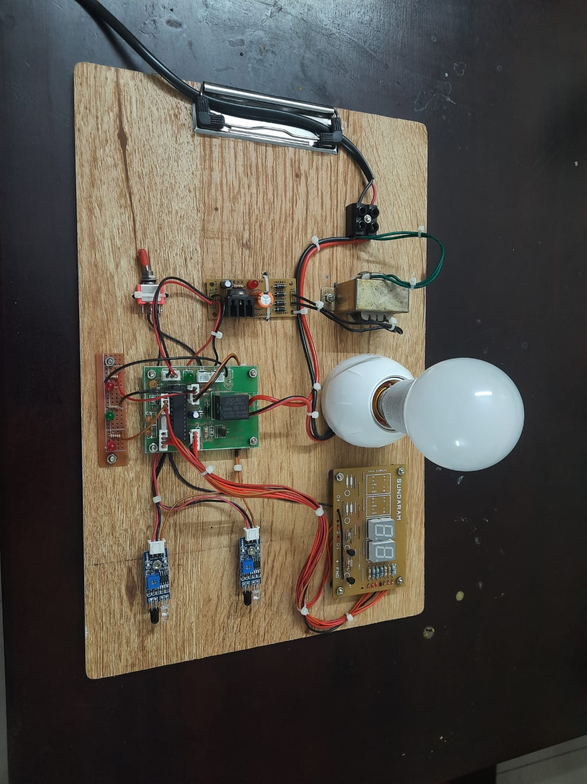

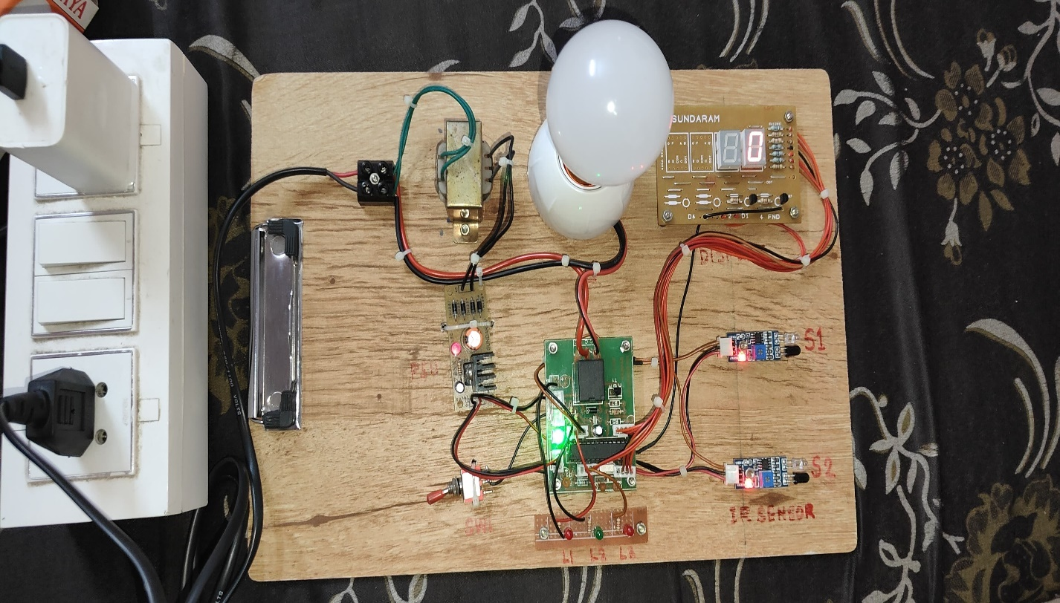

**Fig 13** **Internal or Component design structure**

**4.1.4 *working principles***

**Efficient power management and integrated billing systems are crucial for optimizing energy consumption and ensuring fair and accurate billing in various industries. Here are some working principles for both aspects:**

**Efficient Power Management**

**1. Real-time Monitoring**

Implement sensors and monitoring devices to collect real-time data on energy usage. Use IoT (Internet of Things) devices for remote monitoring and control of power-consuming equipment.

**2. Data Analytics**

Employ advanced analytics to analyze historical and real-time data to identify patterns, anomalies, and opportunities for optimization.Utilize machine learning algorithms to predict energy usage patterns and optimize consumption**.**

**3. Load Shedding and Peak Demand Management**

Implement load shedding strategies during peak demand periods to reduce overall power consumption. Use smart grid technologies to manage and distribute energy efficiently.

**4. Energy Storage Solutions**

Integrate energy storage systems (e.g., batteries) to store excess energy during low-demand periods and release it during peak hours**.**

**5. Energy-efficient Equipment**

Invest in energy-efficient appliances and machinery to reduce overall power consumption. Implement energy-saving technologies, such as LED lighting and energy-efficient HVAC systems.

**6. Demand Response Programs**

Engage in demand response programs to encourage consumers to adjust their power usage during peak hours

**Integrated Billing System**

**1. Metering and Data Collection**

Deploy smart meters to accurately measure and record energy consumption.Ensure seamless data collection and transmission from meters to the central billing system.

**2. Automated Billing Processes**

Implement automated billing systems to reduce errors and streamline the billing process. Utilize billing software to generate invoices, track payments, and manage customer accounts**.**

**3. Tariff Structures**

Define transparent and fair tariff structures that consider peak and off-peak hours, varying rates, and special discounts. Communicate tariff structures clearly to customers to promote understanding and compliance.

**4. Data Security and Privacy**

Implement robust security measures to protect customer data and billing information. Comply with data privacy regulations and ensure customer trust by safeguarding their sensitive information.

**5. Customer Engagement**

Provide customers with access to their energy consumption data through online portals or mobile apps. Implement customer education programs to raise awareness about energy conservation and billing practices.

**6. Flexible Payment Options**

Offer multiple payment options, such as online payments, direct debit, and mobile payment solutions. Provide flexibility in billing cycles and payment plans to accommodate diverse customer needs.

**7. Billing Transparency**

Ensure transparency in billing by providing detailed breakdowns of charges and explaining any adjustments or discrepancies.Respond promptly to customer inquiries and concerns regarding their bills.

By combining these principles, organizations can create a comprehensive and efficient power management and integrated billing system that benefits both the service providers and consumers.

**4.1.5 source code [Integrated Billing System (sw)]**

#include <iostream>

#include <vector>

#include <string>

#include <iomanip>

#include <ctime>

#include <sstream>

#ifdef _WIN32

#include <conio.h>

#else

#include <termios.h>

#include <unistd.h>

#endif

using namespace std;

int getch() {

#ifdef _WIN32

return _getch();

#else

char buf = 0;

struct termios old = {0};

struct termios newTerm = {0};

fflush(stdout);

if (tcgetattr(0, &old) < 0)

perror("tcsetattr()");

newTerm = old;

newTerm.c_lflag &= ~ICANON;

newTerm.c_lflag &= ~ECHO;

newTerm.c_cc[VMIN] = 1;

newTerm.c_cc[VTIME] = 0;

if (tcsetattr(0, TCSANOW, &newTerm) < 0)

perror("tcsetattr ICANON");

if (read(0, &buf, 1) < 0)

perror("read()");

old.c_lflag |= ICANON;

old.c_lflag |= ECHO;

if (tcsetattr(0, TCSADRAIN, &old) < 0)

perror("tcsetattr ~ICANON");

return buf;

#endif

}

class Transaction {

public:

std::string date;

double amount;

Transaction(double amount) : amount(amount) {

time_t now = time(0);

tm* currentDateTime = localtime(&now);

char dateBuffer[20];

strftime(dateBuffer, sizeof(dateBuffer), "%Y-%m-%d %H:%M:%S", currentDateTime);

date = dateBuffer;

}

};

enum ElectricityType {

DOMESTIC,

COMMERCIAL

};

class Bill {

public:

int id;

string vendorName;

double amount;

string dueDate;

string status;

ElectricityType electricityType;

std::vector<Transaction> transactionHistory;

Bill(int id, const string& vendorName, double amount, const string& status, ElectricityType electricityType)

: id(id), vendorName(vendorName), amount(amount), status(status), electricityType(electricityType) {

time_t now = time(0);

tm* currentDateTime = localtime(&now);

char dateBuffer[11];

strftime(dateBuffer, sizeof(dateBuffer), "%Y-%m-%d", currentDateTime);

dueDate = dateBuffer;

}

};

int billIdCounter = 1;

void addBill(vector<Bill>& bills, const string& vendorName, double amount, const string& status, ElectricityType electricityType) {

Bill newBill(billIdCounter++, vendorName, amount, status, electricityType);

time_t now = time(0);

tm* currentDateTime = localtime(&now);

currentDateTime->tm_mday += 10;

mktime(currentDateTime);

char dateBuffer[11];

strftime(dateBuffer, sizeof(dateBuffer), "%Y-%m-%d", currentDateTime);

newBill.dueDate = dateBuffer;

tm dueDateTime = {};

istringstream dateStream(newBill.dueDate);

dateStream >> get_time(&dueDateTime, "%Y-%m-%d");

if (mktime(&dueDateTime) < mktime(currentDateTime)) {

cout << "Due date exceeded by more than 10 days. Rs. 100 fine added.\n";

newBill.amount += 100.0;

}

Transaction transaction(amount);

newBill.transactionHistory.push_back(transaction);

if (vendorName == "Deposit") {

newBill.status = "Paid";

newBill.dueDate = "";

}

bills.push_back(newBill);

cout << "Bill added successfully.\n";

}

void viewBills(const vector<Bill>& bills, bool isGeneralUser) {

if (bills.empty()) {

cout << "No bills found.\n";

return;

}

cout << setw(5) << "ID" << setw(20) << "Vendor Name" << setw(10) << "Amount" << setw(15) << "Due Date" << setw(10) << "Status" << setw(15) << "Electricity Type" << endl;

cout << setfill('-') << setw(80) << "-" << setfill(' ') << endl;

time_t now = time(0);

tm* currentDateTime = localtime(&now);

for (const Bill& bill : bills) {

cout << setw(5) << bill.id << setw(20) << bill.vendorName << setw(10) << bill.amount;

if (bill.vendorName != "Deposit") {

cout << setw(15) << bill.dueDate;

} else {

cout << setw(15) << "N/A";

}

cout << setw(10) << bill.status;

if (bill.electricityType == DOMESTIC) {

cout << setw(15) << "Domestic";

} else if (bill.electricityType == COMMERCIAL) {

cout << setw(15) << "Commercial";

}

if (isGeneralUser && bill.status == "Unpaid" && bill.vendorName != "Deposit") {

tm dueDateTime = {};

istringstream dateStream(bill.dueDate);

dateStream >> get_time(&dueDateTime, "%Y-%m-%d");

if (mktime(&dueDateTime) < mktime(currentDateTime)) {

int daysRemaining = (mktime(&dueDateTime) - mktime(currentDateTime)) / (60 * 60 * 24);

if (daysRemaining <= 10) {

cout << " (Due in " << daysRemaining << " days)";

} else {

cout << " (Due in more than 10 days)";

}

}

}

cout << endl;

}

}

void markAsPaid(vector<Bill>& bills, int billId) {

for (Bill& bill : bills) {

if (bill.id == billId) {

bill.status = "Paid";

cout << "Bill marked as paid.\n";

return;

}

}

cout << "Bill not found.\n";

}

void viewTransactionHistory(const vector<Bill>& bills) {

if (bills.empty()) {

cout << "No transaction history available.\n";

return;

}

cout << setw(5) << "Bill ID" << setw(20) << "Vendor Name" << setw(10) << "Amount" << setw(20) << "Date" << endl;

cout << setfill('-') << setw(60) << "-" << setfill(' ') << endl;

for (const Bill& bill : bills) {

for (const Transaction& transaction : bill.transactionHistory) {

cout << setw(5) << bill.id << setw(20) << bill.vendorName << setw(10) << transaction.amount << setw(20) << transaction.date << endl;

}

}

}

ElectricityType getElectricityType(int choice) {

switch (choice) {

case 1:

return ElectricityType::DOMESTIC;

case 2:

return ElectricityType::COMMERCIAL;

default:

return ElectricityType::DOMESTIC;

}

}

int main() {

vector<Bill> bills;

int choice;

int userRole;

do {

cout << "+-----------------------------------------------+" << endl;

cout << "| \"Efficient Power Management and |" << endl;

cout << "| Integrated Billing System\" |" << endl;

cout << "+-----------------------------------------------+" << endl;

cout << "1. General Login \n";

cout << "2. Admin Login\n";

cout << "3. Exit\n";

cout << "Select your Login: ";

cin >> userRole;

switch (userRole) {

case 1:

{

// General user login

int generalUserChoice;

do {

cout << "\nGeneral User Menu\n";

cout << "1. Calculate Electricity Bill\n";

cout << "2. Deposit Money\n";

cout << "3. Notifications\n";

cout << "4. Logout\n";

cout << "Select your Options: ";

cin >> generalUserChoice;

switch (generalUserChoice) {

case 1: {

int electricityTypeChoice;

int n,x;

double total_bill;

cout << "Choose electricity type (1 for Domestic, 2 for Commercial): ";

cin >> electricityTypeChoice;

if (electricityTypeChoice == 1 || electricityTypeChoice == 2) {

if (electricityTypeChoice == 1) {

cout << "Total Number of Units used: ";

cin >> n;

if (n > 0 && n < 101){

total_bill = (n * 4.80);}

if (n > 100 && n < 201){

total_bill = (n * 5.80);}

if (n > 200){

total_bill = (n * 6.50);}

cout << "--------------------------------------------" << endl;

cout << "Total bill = RS." << total_bill<< endl;

cout << "--------------------------------------------" << endl;

}

else if (electricityTypeChoice == 2) {

cout << "Total Number of Persons : ";

cin >> x;

cout << "Total Number of Units used: ";

cin >> n;

if (n > 0 && n < 101){

total_bill = (n * 6.05);}

if (n > 100){

total_bill = (n * 6.70);}

cout << "--------------------------------------------" << endl;

cout << "Total bill = RS." << total_bill<< endl;

cout << "--------------------------------------------" << endl;

cout<<"Bill Per Each Person is :"<<total_bill/x<<endl;

cout << "--------------------------------------------" << endl;

}

addBill(bills, "Electricity", total_bill, "Unpaid", getElectricityType(electricityTypeChoice));

}else {

cout << "Invalid choice for electricity type.\n";

}

break;

}

case 2: {

double depositAmount;

int electricityTypeChoice;

cout << "Choose electricity type for deposit (1 for Domestic, 2 for Commercial): ";

cin >> electricityTypeChoice;

cout << "Enter deposit amount: ₹ ";

cin >> depositAmount;

// Assuming some initial deposit

addBill(bills, "Deposit", depositAmount, "Paid", getElectricityType(electricityTypeChoice));

cout << "Deposit of ₹" << depositAmount << " successful.\n";

break;

}

case 3: {

cout << "\nNotifications\n";

cout << "------------------------------------------------------------------------------------\n";

viewBills(bills, true);

cout << "-------------------------------------------------------------------------------------\n";

break;

}

case 4:

cout << "Exiting User Menu.\n";

break;

default:

cout << "Invalid choice. Please try again.\n";

}

} while (generalUserChoice != 4);

break;

}

case 2:

{

string enteredPassword;

string correctPassword = "admin123";

cout << "Enter Admin password: ";

char ch;

string password;

while ((ch = getch()) != '\n') {

password.push_back(ch);

cout << '*';

if (password == "admin123") {

break;

}

}

cout << endl;

if (password != correctPassword) {

cout << "Incorrect password. Exiting Admin Login.\n";

break;

}

do {

cout << "\nAdmin Menu\n";

cout << "1. Add Bill\n";

cout << "2. View Bills\n";

cout << "3. View Transaction History\n";

cout << "4. Mark as Paid\n";

cout << "5. Logout\n";

cout << "Select your Options: ";

cin >> choice;

switch (choice) {

case 1: {

// Admin can add a bill

string vendorName;

double amount;

int electricityTypeChoice;

cout << "Enter Vendor Name: ";

cin.ignore(); // Ignore any previous newline character in the buffer

getline(cin, vendorName);

cout << "Enter Amount: ";

cin >> amount;

cout << "Choose electricity type (1 for Domestic, 2 for Commercial): ";

cin >> electricityTypeChoice;

addBill(bills, vendorName, amount, "Unpaid", getElectricityType(electricityTypeChoice));

break;

}

case 2:

viewBills(bills, false);

break;

case 3:

viewTransactionHistory(bills);

break;

case 4: {

int billId;

cout << "Enter the ID of the bill to mark as paid: ";

cin >> billId;

markAsPaid(bills, billId);

break;

}

case 5:

cout << "Exiting Admin Menu.\n";

break;

default:

cout << "Invalid choice. Please try again.\n";

}

} while (choice != 5);

break;

}

case 3:

cout << "Exiting the program.\n";

break;

default:

cout << "Invalid choice. Please try again.\n";

}

} while (userRole != 3);

return 0;

}

**4.1.6 source code [ Efficient Power Management(HW) ]**

//Tested OK

#include <TimerOne.h>

#include <Multiplex7Seg.h>

const int button1Pin = A2; // the pushbutton1 is connected to A0

const int button2Pin = A3; // the pushbutton1 is connected to A2

const int LED1 = A4;

const int LED2 = A5;

const int Relay = 13;

const int RelayOnLed = 2;

byte digitPins[] = {3, 4}; // LSB to MSB

byte segmentPins[] = {12, 11, 10, 9, 8, 7, 6}; // Segment a to g

int count = 0;

int Reset1 = 0;

int Reset2 = 0;

int HeadCount = 0;

boolean enter1Status = LOW;

boolean leave1Status = LOW;

boolean enter2Status = LOW;

boolean leave2Status = LOW;

boolean Toggle1 = LOW;

boolean Toggle2 = LOW;

boolean EnableVar = LOW;

int button1State = 0; // variable for reading the pushbutton1's status

int button2State = 0; // variable for reading the pushbutton2's status

void setup()

{

Serial.begin(9600);

pinMode(LED1, OUTPUT);

pinMode(LED2, OUTPUT);

pinMode(Relay, OUTPUT);

pinMode(RelayOnLed, OUTPUT);

// initialize the pushbutton pins as an inputs:

Multiplex7Seg::set(1, 2, digitPins, segmentPins); // Initialize

// See the example in Multiplex7Seg library for initialization parameters

Timer1.initialize(100000); //100 ms interrupt

Timer1.attachInterrupt(EnterCheck);

}

void loop()

{

button1State = digitalRead(button1Pin);

if (button1State == LOW && enter1Status == LOW && Reset1 == 0)

{

Reset1 = 1;

enter1Status = HIGH;

delay(200);

}

button2State = digitalRead(button2Pin);

if (button2State == LOW && enter2Status == LOW && Reset1 == 1)

{

Reset1 = 2;

digitalWrite(LED1, HIGH);

enter2Status = HIGH;

delay(200);

interrupts();

}

if(Reset1 == 2 && Toggle1 == LOW)

{

Toggle1 = HIGH;

HeadCount = HeadCount + 1;

Serial.println(HeadCount);

delay(200);

}

button2State = digitalRead(button2Pin);

if (button2State == LOW && leave2Status == LOW && Reset2 == 0)

{

Reset2 = 1;

leave2Status = HIGH;

delay(200);

}

button1State = digitalRead(button1Pin);

if (button1State == LOW && leave1Status == LOW && Reset2 == 1)

{

Reset2 = 2;

digitalWrite(LED2, HIGH);

leave1Status = HIGH;

delay(200);

interrupts();

}

if(Reset2 == 2 && Toggle2 == LOW)

{

Toggle2 = HIGH;

HeadCount = HeadCount - 1;

if(HeadCount == -1)

HeadCount = 0;

Serial.println(HeadCount);

delay(200);

}

Multiplex7Seg::loadValue(HeadCount); // Display incrementing value

if(HeadCount > 0)

{

digitalWrite(Relay, HIGH);

digitalWrite(RelayOnLed, HIGH);

}

else

{

digitalWrite(Relay, LOW);

digitalWrite(RelayOnLed, LOW);

}

delay(100);

}

void EnterCheck()

{

if(enter2Status == HIGH || leave2Status == HIGH)

{

count = count + 1;

if(count > 10)

{

count = 0;

digitalWrite(LED1, LOW);

digitalWrite(LED2, LOW);

enter1Status = LOW;

enter2Status = LOW;

leave1Status = LOW;

leave2Status = LOW;

Reset1 = 0;

Reset2 = 0;

Toggle1 = LOW;

Toggle2 = LOW;

noInterrupts();

}

}

}

**4.1.7 Sample hex format**

:100000000C9462000C948A000C948A000C948A0070

:100010000C948A000C948A000C948A000C948A0038

:100020000C948A000C94ED030C948A000C948A00C2

:100030000C948A000C946E050C948A000C948A002F

:100040000C94A3030C948A000C9471030C944B033E

:100050000C948A000C948A000C948A000C948A00F8

:100060000C948A000C948A000000000023002600F3

:10007000290000000008000201000003040700003E

:1000800000000000000000000000250028002B00F8

:1000900000000000240027002A00040404040404D3

:1000A0000404020202020202030303030303010227

:1000B00004081020408001020408102001020408F6

:1000C0001020AF0711241FBECFEFD8E0DEBFCDBF99

:1000D00011E0A0E0B1E0ECE5F0E102C005900D9286

:1000E000A032B107D9F721E0A0E2B1E001C01D9232

:1000F000AD3EB207E1F710E0C2E6D0E004C02197C0

:10010000FE010E941208C136D107C9F70E94950569

:100110000C942C080C94000090E0FC01E255FF4F79

:10012000249186569F4FFC018491882399F090E09A

:10013000880F991FFC01E057FF4FA591B491FC0176

:10014000EA57FF4F859194918FB7F894EC91E22B89

:10015000EC938FBF0895AF92BF92CF92DF92EF9250

**4.2.1 Implementation screenshots**

**Step 1: Navigate to the General Login section**

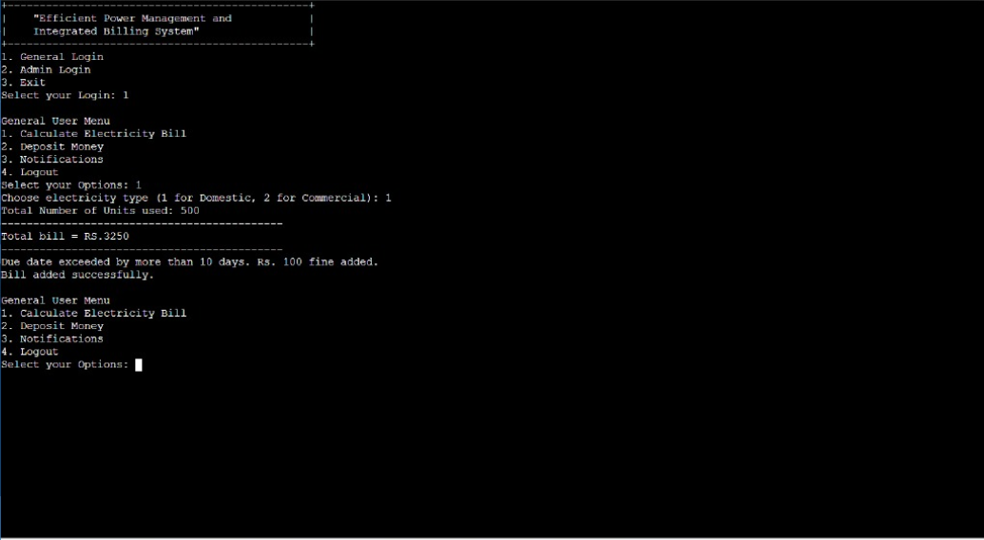

**Fig 4.1.5.1: General Login**

**Step 2: choose the option labelled [i] to calculate the electricity bill**

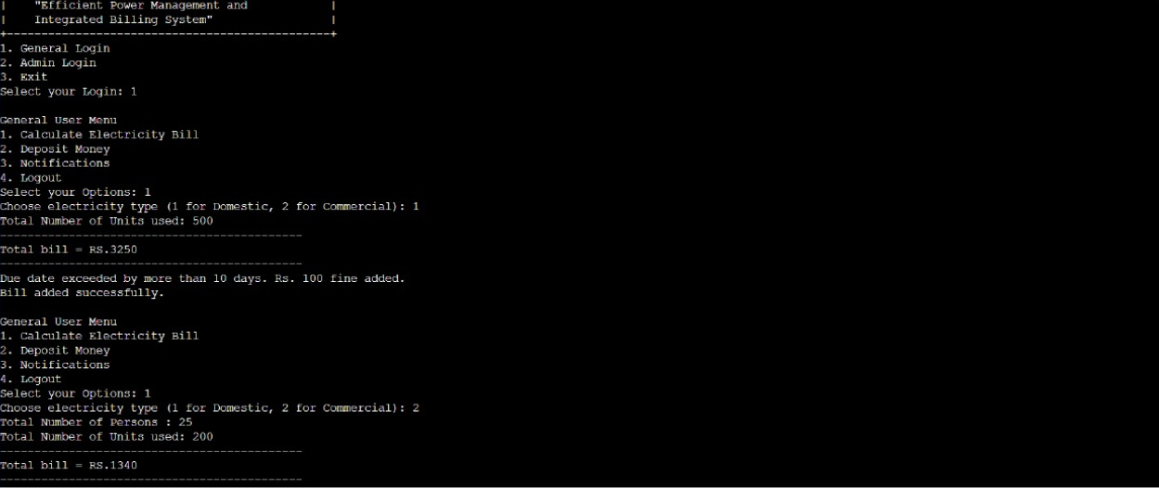

**Fig 4.1.5.2: calculate electricity bill**

**Step 3: : opt for option [ii] to deposit Money** 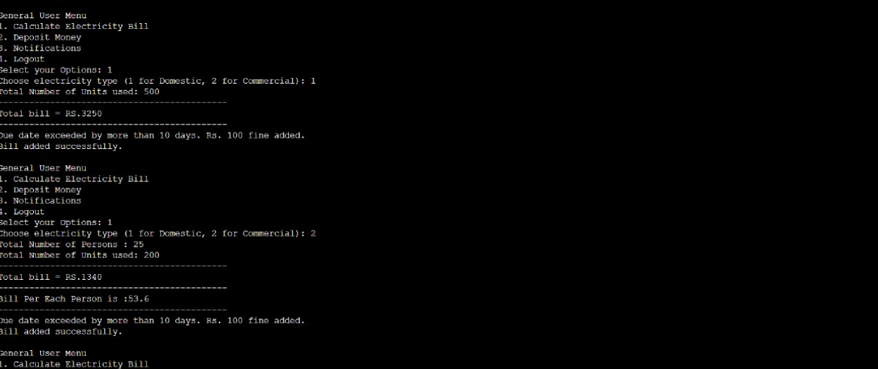

**Fig 4.1.5.3: Deposited Money**

**Step 4: Access notifications by selecting option [iii]**

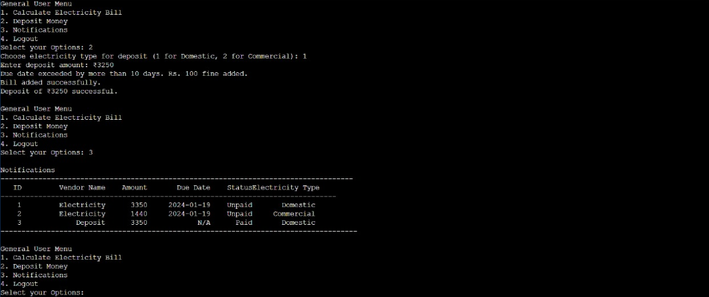

**Fig 4.1.5.4: Notification History**

**Step 5: Exit the system by selecting the exit option**

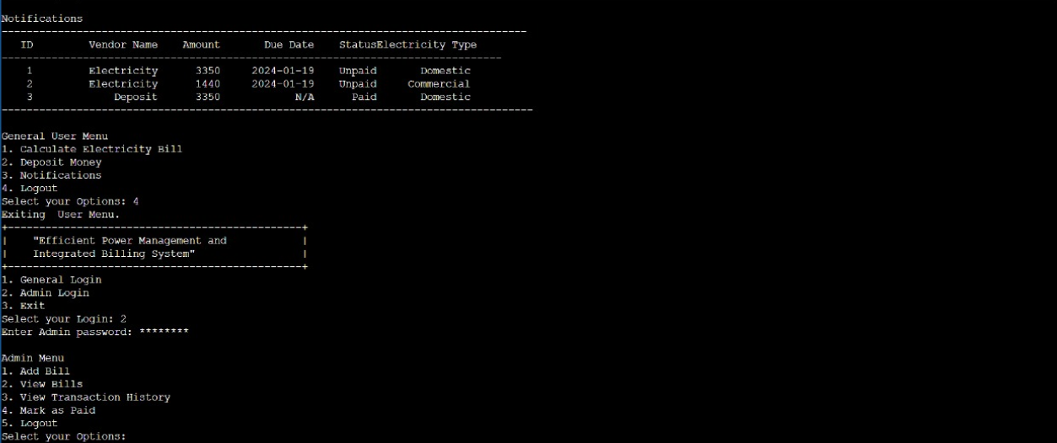

**Fig 4.1.5.5: system successfully Exited**

**Step 6: Go to the admin login section**

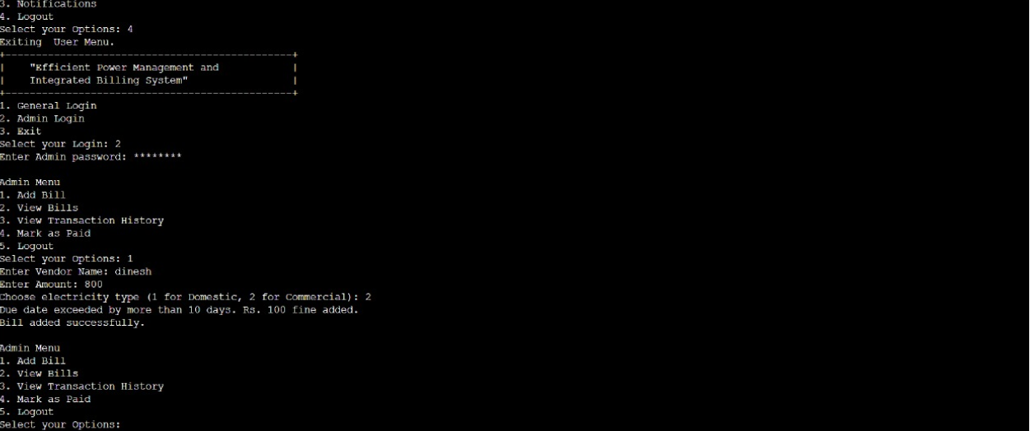

**Fig4.1.5.6: Admin Login Page**

**Step 7: Select option [i] to add bill**

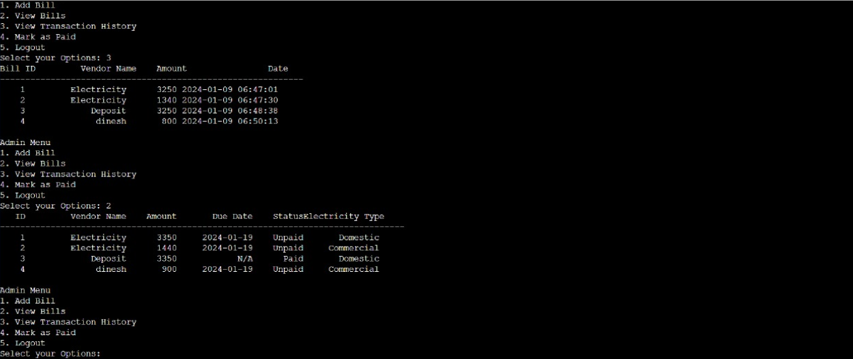

**Fig 4.1.5.7: Add Bill**

**Step 8:** **choose option [iii] to view transaction history** 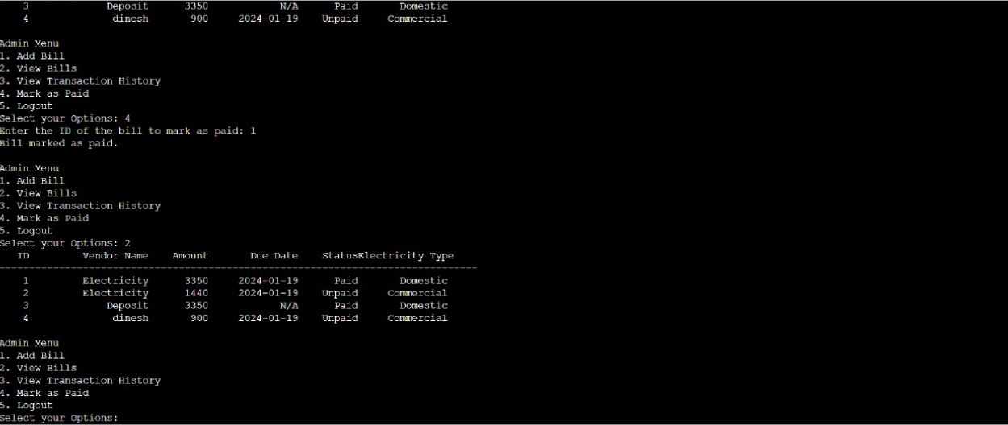

**Fig 4.1.5.8: Transaction History**

**Step 9**: **Select option [v] to exit current page**

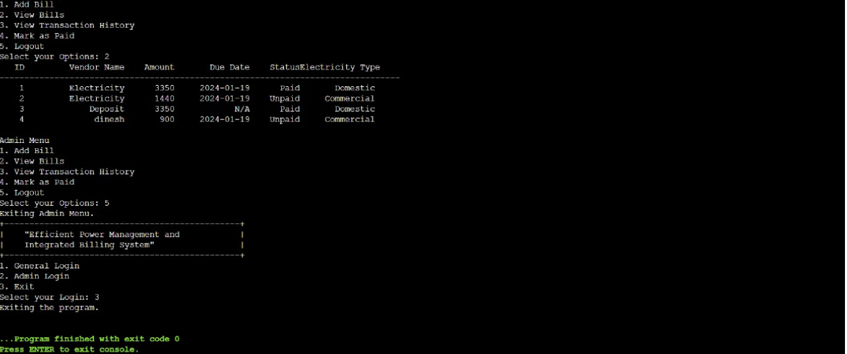

**Fig 4.1.5.9: system exited**

**1. HARDWARE OUTPUT FOR DOMESTIC (WITHOUT COUNTING)**

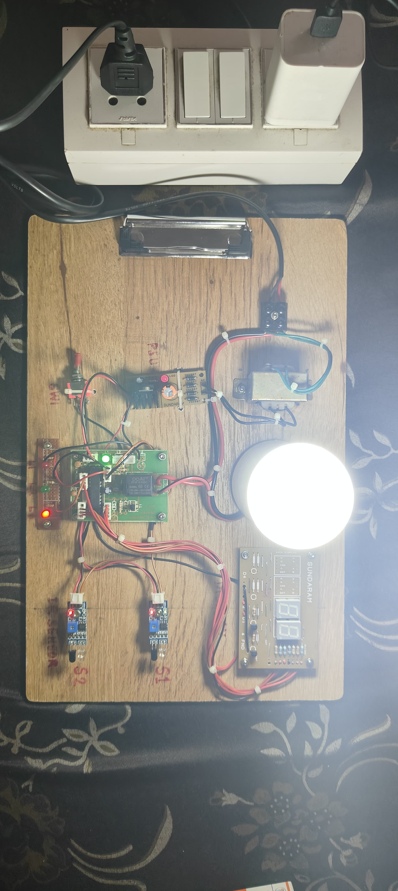

**Fig 5 : Domestic output**

**2. HARDWARE OUTPUT FOR COMMERCIAL (WITH COUNTING)**

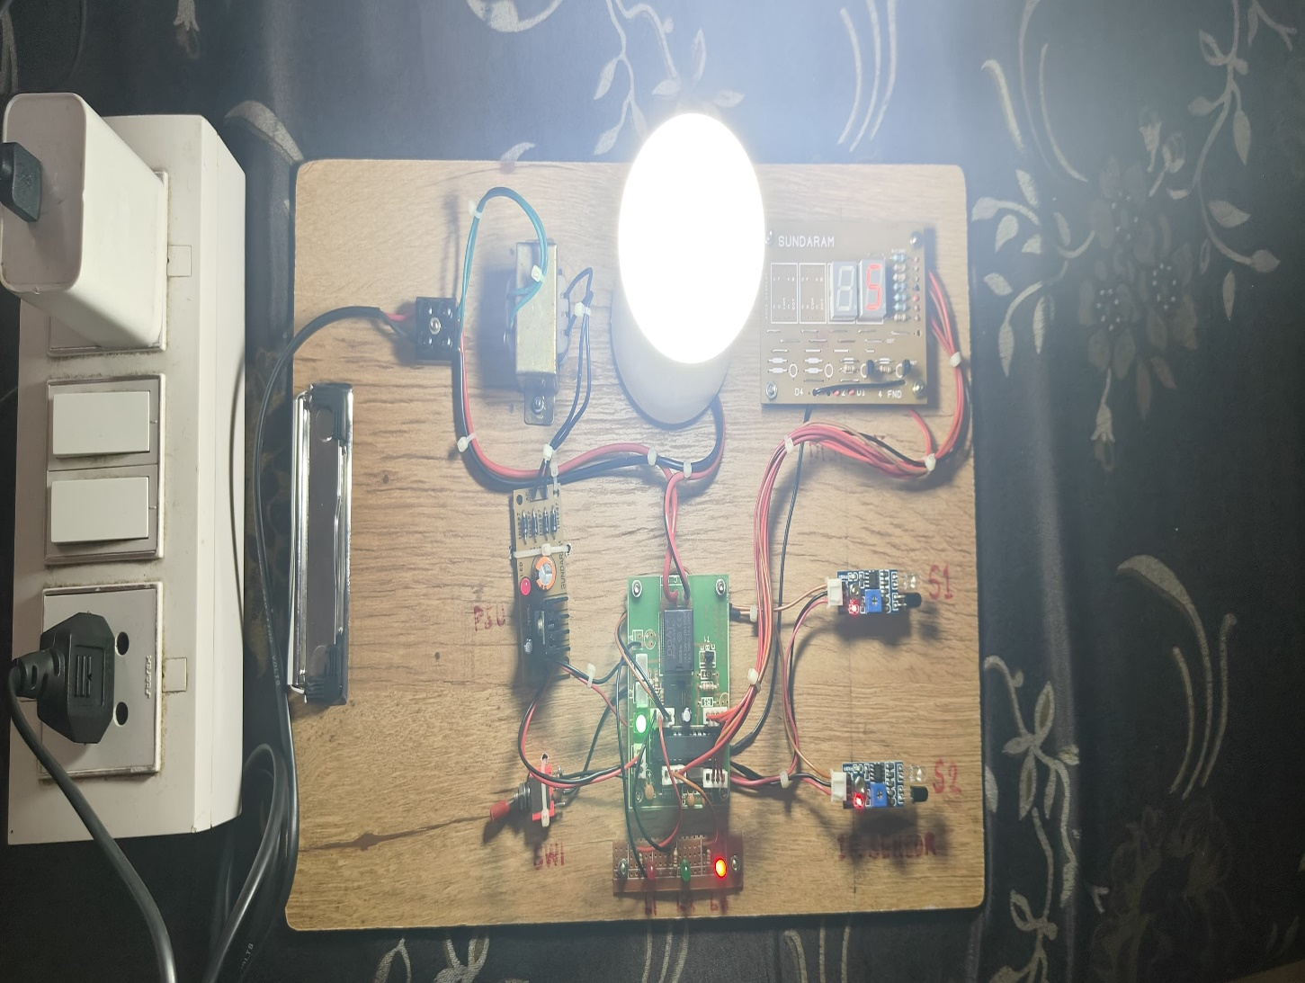

**Fig 5 : Commercial output**

**3.MONITORING THE PERSON (0-5)**

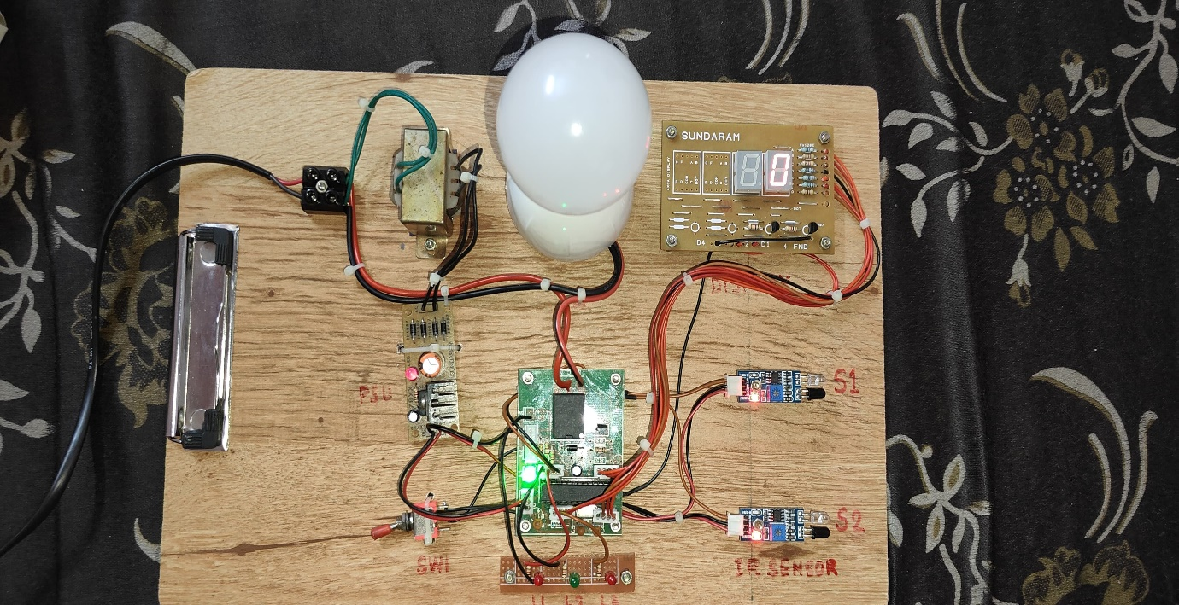

**Fig 5.1 Initial Value (0)**

**4.AFTER ENTERING**

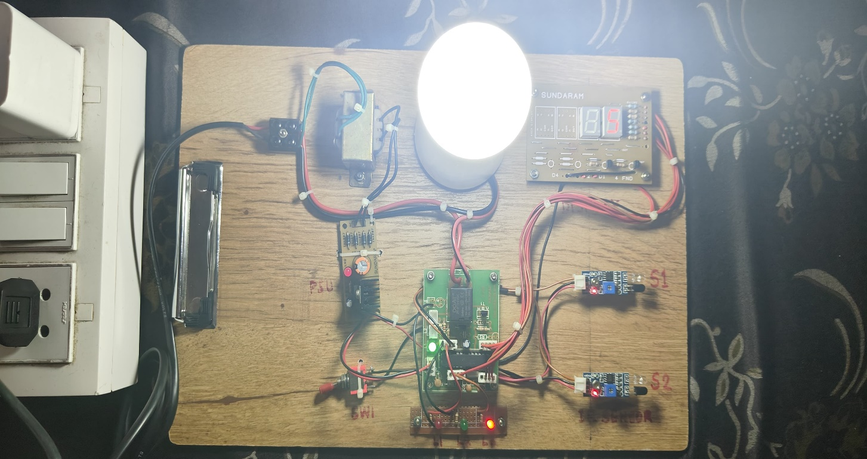

**Fig 5.2 Counting Values (0-5)**

**4.2 FEATURES**

Efficient power management and integrated billing systems are crucial components for optimizing energy usage and ensuring fair and transparent billing. Here are some key features for such systems:

**1. Real-time Monitoring**

Continuous monitoring of power consumption in real-time. Instant alerts forabnormal power usage or system failures**.**

**2. Smart Metering**

Integration with smart meters for accurate and automated data collection.Two-way communication for remote monitoring and control**.**

**3. Demand Response**

Ability to implement demand response strategies to adjust power consumption during peak times.

Incentive programs to encourage users to reduce demand during high-energy costperiods.

**4. Load Shedding and Load Balancing**

Automated load shedding during peak hours or emergencies.

Intelligent load balancing to distribute power usage evenly across different components**.**

**5. Predictive Analytics**

Utilization of predictive analytics to forecast energy demand and optimize resource allocation. Machine learning algorithms for trend analysis and anomaly detection.

**6. Energy Efficiency Recommendations**

Provide personalized recommendations to users for optimizing energy consumption based on historical data. Integration with smart devices to automate energy-saving measures.

**7. Billing Transparency**

Transparent and detailed billing statements for end-users.

Access to a user-friendly portal for reviewing consumption patterns, billing history,and cost breakdowns.

**8. Automated Billing and Invoicing**

Automated generation and distribution of bills based on actual consumption.Multiple billing options, including time-of-use rates and tiered pricing.

**9. Payment Integration**

Integration with various payment gateways for convenient and timely payments.Options for automated payments and alerts for overdue bills.

**10. User Authentication and Security**

Secure authentication protocols to ensure only authorized users can access and control the system.

Data encryption to protect sensitive information related to energy consumption and billing

Compliance with local and international regulations related to energy management and billing.Regular updates to adapt to changing regulatory requirements.

Implementing a system with these features can significantly contribute to efficient power management and a transparent, integrated billing process.

**4.2.1 *Novelty of the proposal***

**The novelty of a proposal for efficient power management and an integrated billing system lies in its ability to address multiple aspects of energy consumption and billing in a holistic and innovative manner. Here are some key elements that can contribute to the novelty of such a proposal**

**1. Smart Grid Integration**

Incorporate smart grid technologies to enhance the efficiency of energy distribution and consumption. This could involve real-time monitoring and control of electricity usage at both the consumer and grid levels.

**2. Predictive Analytics**

Utilize advanced predictive analytics to forecast energy demand patterns. This enables proactive decision-making and optimization of power distribution, reducing wastage and improving overall system efficiency**.**

**3.Demand Response Mechanism**

Implement a dynamic demand response mechanism that encourages consumers to adjust their electricity usage during peak hours. This can be facilitated through automated notifications, incentives, or smart home devices.

**4. Blockchain Technology for Billing**

Integrate blockchain technology for secure and transparent billing. This can ensure accurate and tamper-proof recording of energy consumption data, as well as streamline the billing process through automated smart contracts.

**5. User-Friendly Interface**

Develop a user-friendly interface for consumers to monitor and manage their energy consumption in real-time. This could include a mobile app or web portal that provides insights, suggestions for energy savings, and transparent billing information**.**

**6. Integration with Renewable Energy Sources**

Facilitate the integration of renewable energy sources into the power grid. The system can prioritize the use of renewable energy when available, providing a more sustainable and eco-friendly power management solution.

**7. Automated Meter Reading (AMR)**

Implement Automated Meter Reading technologies to collect consumption data remotely. This reduces the need for manual readings, minimizes errors, and enhances the accuracy of billing.

**8. Customizable Billing Plans**

Introduce customizable billing plans that cater to different consumer needs and encourage energy-efficient behavior. This could include time-of-use pricing, tiered billing, or other innovative models.

**9. Energy-Efficient Appliances Incentives**

Collaborate with manufacturers and retailers to promote the use of energy-efficient appliances. Introduce incentives for consumers who adopt these technologies, contributing to overall energy savings.

**10. Cybersecurity Measures**

Prioritize cybersecurity measures to protect consumer data and ensure the integrity of the power management and billing system. Implement robust encryption, authentication, and authorization protocols.

By combining these elements, a proposal for efficient power management and an integrated billing system can stand out as a comprehensive and forward-thinking solution that not only addresses current challenges but also paves the way for a more sustainable and technologically advanced energy future.

**CHAPTER 5**

**CONCLUSION**

The proposal for an efficient power management and integrated billing system represents a transformative approach to the evolving landscape of energy consumption and billing. By seamlessly integrating smart grid technologies, predictive analytics, and blockchain innovation, this proposal envisions a future where power distribution is not only optimized for efficiency but also made transparent, secure, and user-centric.The emphasis on a user-friendly interface empowers consumers to actively engage with their energy consumption, fostering a culture of awareness and responsible energy use. The introduction of a dynamic demand response mechanism further contributes to a sustainable energy ecosystem, allowing consumers to play a role in shaping the energy landscape.The low cost power controlling and maintaining device maybe very helpful to the people, which will helpful to the people to reduce the usage of electricity more effectively. This project can be extended by connecting thevarious devices. Overall, an efficient power management and integrated billing system is a valuable tool in creating a more sustainable and cost-effective future. It is important for businesses and individuals to embrace this technology and work towards a more efficient and environmentally friendly energy usage.

In essence, the proposal not only addresses the immediate need for efficient power management and billing but also lays the foundation for a resilient, adaptive energy infrastructure. As we navigate the complexities of a rapidly changing world, this integrated approach stands as a beacon of innovation, ushering in an era where energy is not only managed intelligently but also serves as a catalyst for a more sustainable and interconnected future.In future we can have an ability to pay the electricitybill after the month by the device itself by connecting thevarious type of devices.We can extend this project in the way of to operatethe power supply operations i.e., to cut down the powersupply when they doesn’t pay the electricity bill.We can also extend this project in the way of we canoperate the devices from our working places itself.

**REFERENCES**

1. McHugh ML. The odds ratio: calculation, usage, and interpretation. BiochemMed. 2009;19:120–6.
2. Simundić AM. Bias in research. Biochem Med. 2013;23:12–5. http://dx.doi.org/10.11613/BM.2013.003.
3. Arimoro, T. A., Oyetunji, A. K., &Odugboye, O. E. (2019). Analysis of Electricity Billing System in Corporate Buildings in Lagos, Nigeria. Studies, 1(6), 10-20.
4. Panthala, S., Islam, N., & Habib, S. A. (2015). Automated industrial load measurement system.
5. Adegboyega, A., Gabriel, A. A., Ademola, A. J., Victor, A. I., &Nigeri, K. (2013). Design and Implementation of an Enhanced Power Billing System for Electricity Consumers in Nigeria. African Journal of Computing & ICT, 6(1).
6. Antoniou, G., Batten, L., Narayan, S., &Parampalli, U. (2009). A privacy preserving e-payment scheme. In Intelligent Distributed Computing III (pp.
7. 197-202). Springer, Berlin, Heidelberg
8. Rahul K. Sai (2016) Advanced Centralized Electricity Billing System Using (IOT). International Journal of Advanced Research in Computer Science and Software Engineering icrosoft Developer Network (MSDN)
9. Li, S., Wang, G., Zhou, J., & Chen, K. (2009). Fair and secure mobile billing systems. Wireless personal communications, 51(1), 81-93.
10. Al-Ani, M. S., &Noory, R. (2012). Billing system design based on internet environment. Editorial Preface, 3(9).
11. Barreto, P. S., Amvame-Nze, G., Silva, C.V., Oliveira, J. S. S., de Carvalho,
12. H. P., Abdalla, H., ... &Puttini, R. (2005, April). A study of billing schemes in an experimental next generation network. In International Conference on Networking (pp. 66-74). Springer, Berlin, Heidelberg
13. Bo, Y., Dongsu, L., &Yumin, W. (2002).An anonymity-revoking e- payment system with a smart card. International Journal on Digital Libraries, 3(4), 291-296
14. Ricks, G.W.D. (March 1896). "Electricity SupplyMeters". Journal of the Institution of Electrical Engineers. 25 (120):57–77. doi:10.1049/jiee1.1896.0005. Student paper read on January 24, 1896 at the Students' Meeting.